# DDL Commands – CREATE, ALTER, DROP

# Analytical Questions set-1

Experiment -2

1)Alter the table STUDENT with following structure.

|  |  |  |
| --- | --- | --- |
| # | Column Name | Constraints |
| 1 | RegNo | PRIMARY  KEY |
| 2 | MobileNo | NOT NULL |

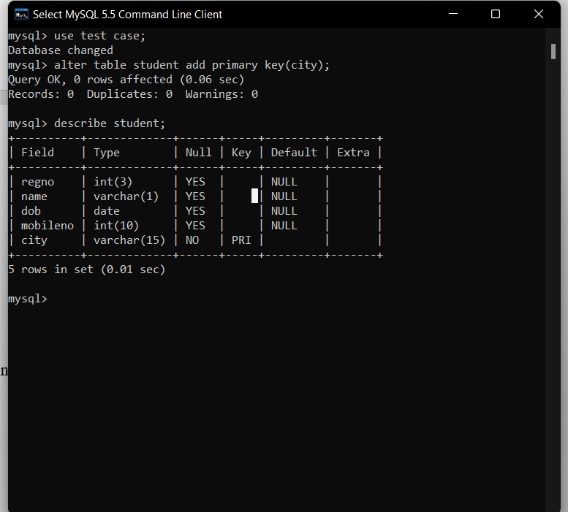

2)Alter the table name FACULTY with following structure. The DeptNo in this table refers the DeptNo in the DEPARTMENT table.

|  |  |  |
| --- | --- | --- |
| # | Column Name | Constraints |
| 1 | FacNo | PRIMARY  KEY |
| 2 | Gender | CHECK  ‘M’ or ‘F’ |

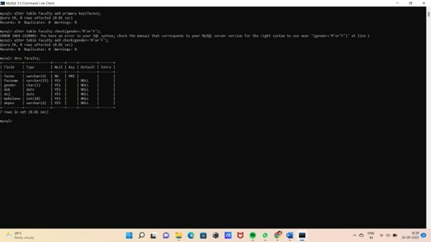

3)After the FACULTY table is successfully created, test if you can add a constraint FOREIGN KEY to the DeptNo of this table.

OUT PUT ::

mysql> alter table faculty add foreign key(deptno);

ERROR 1068 (42000): Multiple primary key defined

4)Alter the table name DEPARTMENT with following structure.

|  |  |  |
| --- | --- | --- |
| # | Column  Name | Constraint |
| 1 | DeptNo | PRIMARY  KEY |



4)Alter the table name COURSE with following structure.

|  |  |  |
| --- | --- | --- |
| # | Column  Name | Constraint |
| 1 | CourseNo | PRIMARY  KEY |
| 2 | SemNo | 1 to 6 |

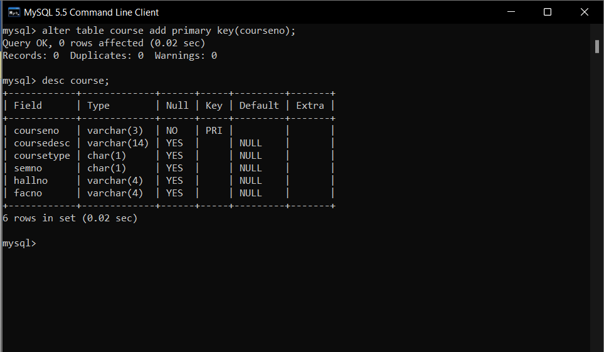

Result: DDL Commands with Primary, Foreign, Unique, Check constraints are updated and verified.